**CMSC203 Assignment 1 Implementation**

1. Class: [**CMSC-203-22507**](https://bb-montgomerycollege.blackboard.com/webapps/blackboard/execute/courseMain?course_id=_104297_1)

 Program: Assignment 1

Instructor:

 Summary of Description: (Give a brief description for each Program)

 Integrity Pledge: I pledge that I have completed the programming assignment independently.

 I have not copied the code from a student or any source.

**Part1: Pseudo Code:** Here is a pseudo code for Assignment 2 program:

**Variables:**

**Input**

**Steps:**

**Declare class wifiDiag**

**Create input variable**

**Print “"reboot the router and try to reconnect"**

**Ask”** **Did that fix the problem? 1 for yes 2 for no”**

**If user says yes end program if no ask “reboot the router and try to reconnect,** **Did that fix the problem? 1 for yes 2 for no” if user says yes end program if no then ask “Make sure the cables between routers and nodes are plugged in firmly,** **Did that fix the problem? 1 for yes 2 for no” if user says yes then end program if no then ask “Move the computer closer to the router and try to connect,** **Did that fix the problem? 1 for yes 2 for no "if user says yes then end program if no then tell them “Contact your ISP" and end program.**

**Part2: Comprehensive Test Plan**

A good test plan should be comprehensive. This means you should have a few test cases that test when the input is in and out of range, division by 0, incorrect Data type, etc (Provide valid and invalid input)

|  |  |  |  |  |
| --- | --- | --- | --- | --- |
| Cases | Input | Expected Output | Actual Output | Did Test Pass? |
| Case 1 | No  No  yes | if you have a problem with internet conectivity, this wifi diagnosis might work  first step: reeboot your computer  are you able to connect to the internet (yes/no)  no  second step: reeboot your router  are you able to connect to the internet (yes/no)  no  third step: make sure the cables to your router are plugged in firmly and your router is getting power  are you able to connect to the internet (yes/no)  yes  re-adjusting your cables seeemed to work  Programmer=Ronit Ghosh | if you have a problem with internet conectivity, this wifi diagnosis might work  first step: reeboot your computer  are you able to connect to the internet (yes/no)  no  second step: reeboot your router  are you able to connect to the internet (yes/no)  no  third step: make sure the cables to your router are plugged in firmly and your router is getting power  are you able to connect to the internet (yes/no)  yes  re-adjusting your cables seeemed to work  Programmer=Ronit Ghosh | yes |
| Case 2 | No  no  no  no  no | if you have a problem with internet conectivity, this wifi diagnosis might work  first step: reeboot your computer  are you able to connect to the internet (yes/no)  no  second step: reeboot your router  are you able to connect to the internet (yes/no)  no  third step: make sure the cables to your router are plugged in firmly and your router is getting power  are you able to connect to the internet (yes/no)  no  fourth step: move your computer closer to your router  are you able to connect to the internet (yes/no)  no  fifth step: contact your ISP  make sure your ISP is hooked up to your router  are you able to connect to the internet (yes/no)  no | if you have a problem with internet conectivity, this wifi diagnosis might work  first step: reeboot your computer  are you able to connect to the internet (yes/no)  no  second step: reeboot your router  are you able to connect to the internet (yes/no)  no  third step: make sure the cables to your router are plugged in firmly and your router is getting power  are you able to connect to the internet (yes/no)  no  fourth step: move your computer closer to your router  are you able to connect to the internet (yes/no)  no  fifth step: contact your ISP  make sure your ISP is hooked up to your router  are you able to connect to the internet (yes/no)  no | yes |
| Case 3 | yes | if you have a problem with internet conectivity, this wifi diagnosis might work  first step: reeboot your computer  are you able to connect to the internet (yes/no)  yes  re-booting your computer seemed to work  Programmer=Ronit Ghosh | if you have a problem with internet conectivity, this wifi diagnosis might work  first step: reeboot your computer  are you able to connect to the internet (yes/no)  yes  re-booting your computer seemed to work  Programmer=Ronit Ghosh | yes |
| Case 4 | No  yes | if you have a problem with internet conectivity, this wifi diagnosis might work  first step: reeboot your computer  are you able to connect to the internet (yes/no)  no  second step: reeboot your router  are you able to connect to the internet (yes/no)  yes  re-booting your router seemed to work  Programmer=Ronit Ghosh | if you have a problem with internet conectivity, this wifi diagnosis might work  first step: reeboot your computer  are you able to connect to the internet (yes/no)  no  second step: reeboot your router  are you able to connect to the internet (yes/no)  yes  re-booting your router seemed to work  Programmer=Ronit Ghosh | yes |

**Part3: Screenshots related to the Test Plan:**

**Case 1**

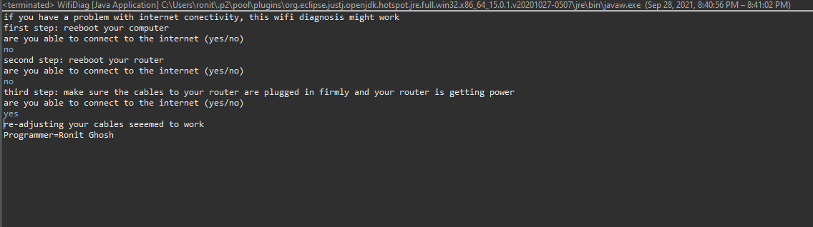

**Case 2**

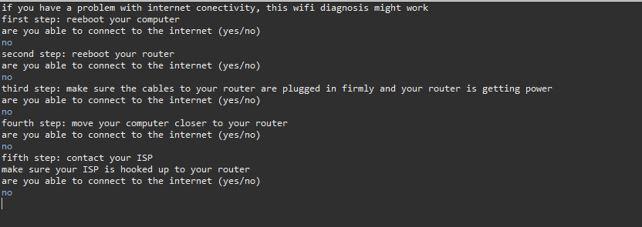

**Case 3**

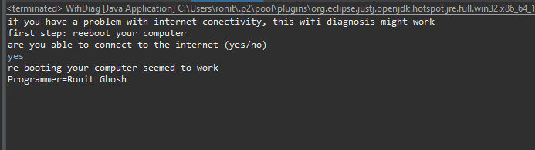

**Case 4**

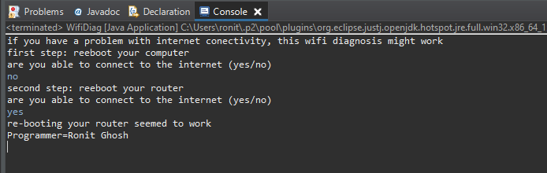

**Lessons Learned** <Provide answers to the questions listed below>**:**

Write about your Learning Experience, highlighting your lessons learned and learning experience from working on this project.

What have you learned?

Using scanner and practicing if statements

What did you struggle with?

Nothing really.

What would you do differently on your next project?

Try using switch statements for practice.

What parts of this assignment were you successful with, and what parts (if any) were you not successful with?

All of the assignment was pretty easy

Provide any additional resources/links/videos you used to while working on this assignment/project.

**Check List:** <Provide answers to the column Y/N or N/A >**:**

|  |  |  |  |
| --- | --- | --- | --- |
| **#** |  | **Y/N** | **Comments** |
|  | **Assignment files:** |  |  |
|  | * FirstInitialLastName_ Assignment#_Moss.zip | **Yes or No** |  |
|  | * FirstInitialLastName_Assignment#.docx/.pdf | **Yes or No** |  |
|  | * Source java files | **Yes or No** |  |
|  | **Program compiles** | **Yes or No** |  |
|  | **Program runs with desired outputs related to a Test Plan** | **Yes or No** |  |
|  | **Documentation file:** |  |  |
|  | * Comprehensive Test Plan | **Yes or No** |  |
|  | * Screenshots related to the Test Plan | **Yes or No** |  |
|  | * Screenshots of your GitHub account with submitted Assignment# (if required) | **Yes or No or N/A** |  |
|  | * UML Diagram (if required) | **Yes or No or N/A** |  |
|  | * Algorithms/Pseudocode (if required) | **Yes or No or N/A** |  |
|  | * Flowchart (if required) | **Yes or No or N/A** |  |
|  | * Lessons Learned | **Yes or No** |  |
|  | * Checklist is completed and included in the Documentation | **Yes or No** |  |

